A000-Am,C-Taino-*Duho*-Parrot Cemi-Basalt-1000 CE

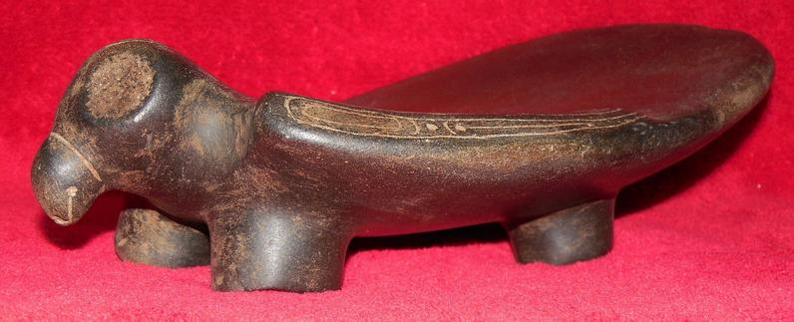

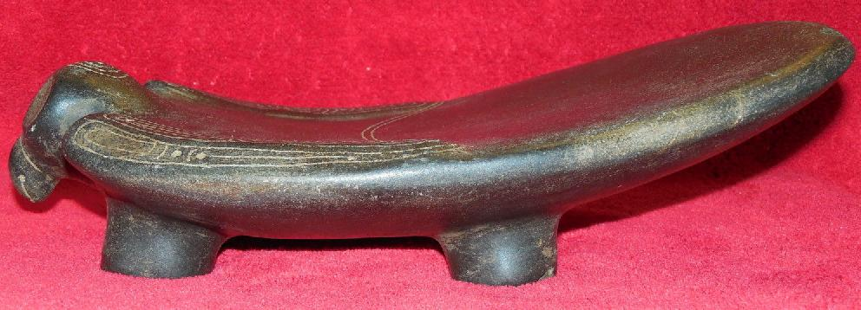

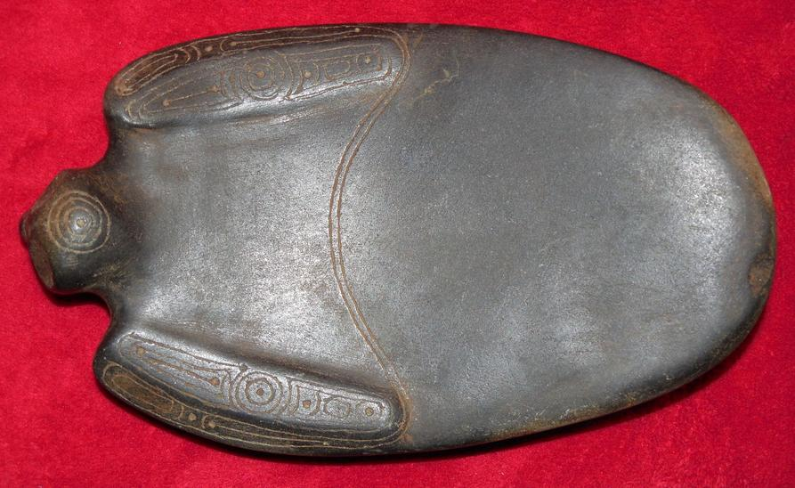

Figs. 1-3. Am,C-Taino-*Duho*-Parrot Effigy-Basalt-1000 CE

Case No.: 18

**Accession No.**

**Formal Label:** Am,C-Taino-*Duho*-Parrot Effigy-Basalt-1000 CE

**Display Description:**

Low horizontal form with concave seat and parrot cemi carved as figurehead with folded wings.

Parrots were one of the most highly revered birds for the Taino because they were the only avvain s[ecies that could be trained to utter Tainos words as though they were humanoids. The ability to speak was intimately tied to the use of masks like the marble mask of *Yucahuguamá*. A similar talking mask was involved in a confrontation with Christopher Columbus. In a portion of Christopher Columbus’ diary quoted by his son Ferdinand it was recorded “It once happened that some Christians [Columbus’ men] entered such a house [with *cemís*] with them [the Taínos], and the *cemí* gave a loud cry and spoke in their language, from which it became clear that the statue was artfully constructed. It was in fact hollow, and to the lower part was attached a blowgun or trumpet which was connected to a dark side of the house, covered by branches and leaves, where was hidden a person who said whatever the cacique wanted him to say … .” (Colón 1959, Ch. 62, 151-152.)

for their economic value, so that a *duho* on which sat a Cacique which was fashioned as a parrot immediately communicated the fact that this man was a great man, at least economically! Oviedo (1526) claimed that there were ”so many different species of parrots that it would be a long task to describe them.” And he shipped a dozen species to the Spanish King Ferdinand with the hope that many of these could talk -- Spanish. Three types were known to the Tainos: Green parrots (*Amazona* sp.), parakeets (*Aratinga* sp.) and Macaws (*Ara* sp.), known as guacamaya, which became extinct in the West Indies in the 19th c. Throughout the West Indies Tainos made capes and crowns of parrot feathers.

Approximately one hundred *duho*s of both wood and stone are in public and private collections world-wide ranging in size from 18 to 122 cm. in length with most originating from Hispaniola (Haiti and the Dominican Republic), Puerto Rico, the Bahamas, Caicos and Turks Islands, and from Cuba and Jamaica which are relatively rarer. The world-wide dispersal of *duho*s began with Columbus and continued as the Spanish settled these islands and sent back artifacts as curiosities along with the small amounts of gold tainted with copper. Prior to contact with Europeans in 1492 these islands had large populations organized into cacicazgos with each cacicazgo having its ruling élites for whom these were made, usually with the form of a shamanic animal or bird as a figurehead. In this example with an owl as a figurehead the owl's wings are slightly raised platforms that are decorated with what might be entoptic, abstract, curvilinear images punctuated with dots which are produced when one is under the influence of hallucinogenic substances during the *cohoba* ritual. Owls were regarded as messengers of the spirits when the *cohoba* ceremony was performed in the darkness of night, the realm of the nocturnal owl. According to Oviedo y Valdes (1851-55 [1535], vol. I:347) the *cohoba* snuff of the **Taino** was obtained from a tree whose pods contained lentil-shaped seeds. It is possible that this particular type of platform could also have functioned as a tobacco or "snuff" tray. However, the gently sloping rear flange of this *duho* (in its side outline view) its shape is not that of a traditional metate or stone grinding platform because the legs are not place at its perimeter but allow the flange to extend so far from the rear legs so as to imbalance it when pressure was applied to it for crushing the snuff. Also, the upper surface contains an intricately engraved double curve connecting the two "wings" of the owl and these engraved lines have not been abraded with grinding or other use. In fact the upper surface has a very smooth patina suggesting extensive contact with human skin.

The dark color of this *duho* was another numinous quality prized by the Taino: darkness was accorded with the night, the realm of spirits and the time of the *cohoba* ceremony. If wooden *duho*s were used they were often made of prized black, hard wood which the Taino valued more than gold to the surprise of the Spanish. The reason was that wood held a numinous power for the Taino, since certain trees were thought to speak to shamans just before the tree was felled and therefore trees were given honorific titles as though they were great caciques (Helms 1987: 71). Similarly dark, hard stone like that of this *duho* was thought to hold a similar numinous power for whomever would be seated on it.

**LC Classification: F1909**

**Date or Time Horizon: 1000 CE**

**Geographical Area: Dominican Republic**

**Geographical Area:** originally from eastern Hispaniola, i.e., theDominican Republic.

**Map:**

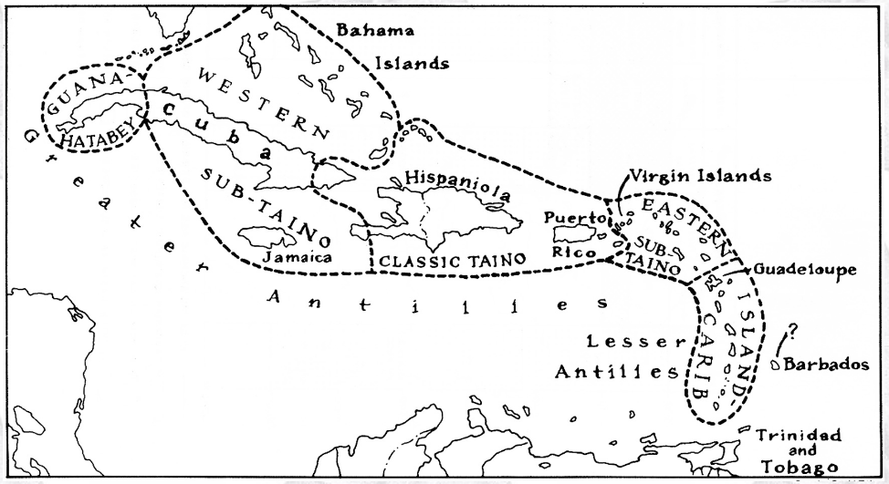

**Caribbean c 1500 after http://www.latinamericanstudies.org/maps/Ciboney-Taino-Carib-**

**GPS coordinates:**

**Cultural Affiliation:** Classic Taino

**Medium: basalt**

**Dimensions:** length 9.5 in., width 5.5 in.,

**Weight:**

**Condition: original**

**Provenance:**

**Discussion:**

*Duho*s performed useful functions as seats for those being honored during social, ceremonial and political events to signify the occasion was one of great importance to the local community by identifying the host and the visitor as individuals of wealth and rank. These occasions were recorded in the early chronicles such as when Columbus sent his envoys to confer with a Cuban cacique (chieftain) who offered his guests gold encrusted *duho*s for the meeting. Similarly Guacanagari, the cacique Columbus visited on Hispaniola, was offered a low platform *duho* like this one with "great courtesy and veneration" (Las Casas 1951, 1: 287).

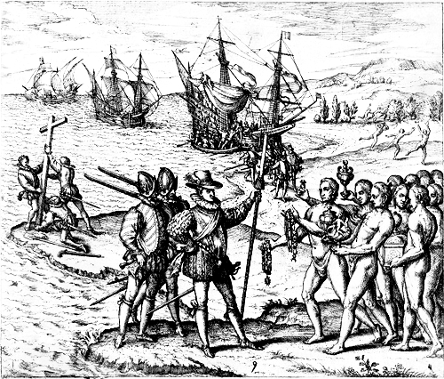

Fig. 4. Christopher Columbus (1451-1506) receiving gifts ostensibly from the cacique, Guacanagari, by Theodore de Bry. However, this engraving is entitled "Columbus, as he first arrives in India, is received by the inhabitants and honored with the bestowing of many gifts." With a cross being hoisted in the background and welcoming Indians in the foreground, we can see some of the many intentions of the Spanish upon their arrival, the primary one of which was gold for hiring the armies to fight the Moorish Muslims back in Spain.

**References:**

Bartolomé de las Casas; Lewis Hanke. 1951. Bartolomé de las Casas: an interpretation of his life and writings. The Hague: Martinus Nijhoff.

Bidó, Rafael Garcia. 2014. *Voces de Bohio vocabulario la cultura Taína*. 2nd ed. Santo Domingo: the author.

# Colón, Fernando. [1959] *The life of the admiral Christopher Columbus*. Translated from *Historie del S.D. Fernando Colombo; nelle qualis'ha paritcolare, & vera relatione della vita, & de' fatti dell'Ammiraglio D. Cristoforo Colombo, suo padre*, annotated, and with a new introduction by Benjamin Keen. New Brunswick, N.J.: Rutgers University Press, [1959].

Helms, Mary W. 1987. Art styles and interaction sphere in central Americaand the Caribbean: polished boack wood in the Greater Antilles. In Robert D. Drennan and Carlos A. Uribe, eds., Chiefdoms in the Americas Lanham, MD: University Press of America.

Zayas y Alfonso, Alfredo. 1914. *Lexicografia antillana. Diccionario de voces usadas por los aborigines de las antillas mayors y algunas de las menorees y considerations acerca de su significado y de su formación.* Havana: El Siglo XX de Aurelio Miranda.

**Appendix:** additional photos of *duho*.

